S3 practivcle

Create a private bucket and add object in it

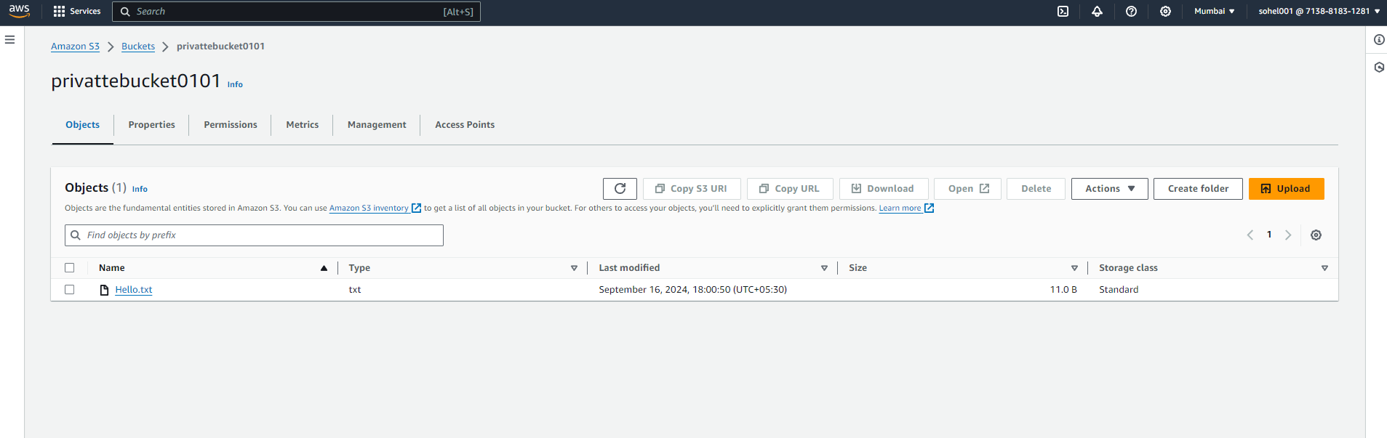

Object is private not able to acces

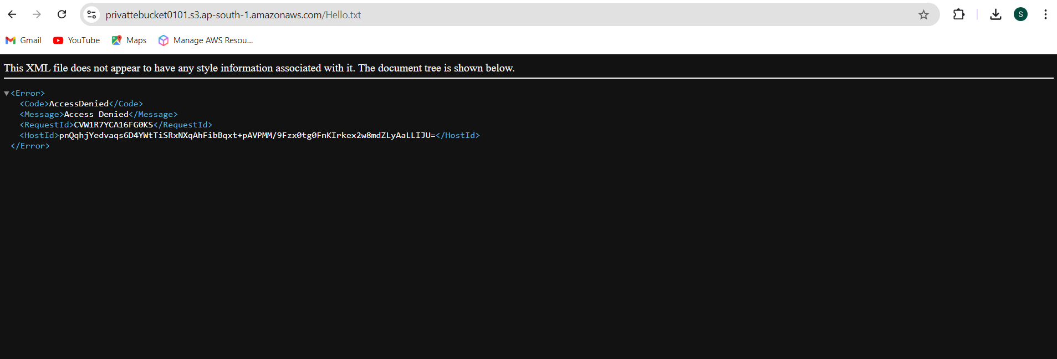

**Making existing bucket as public**

**A.**Unchecked the tick box.

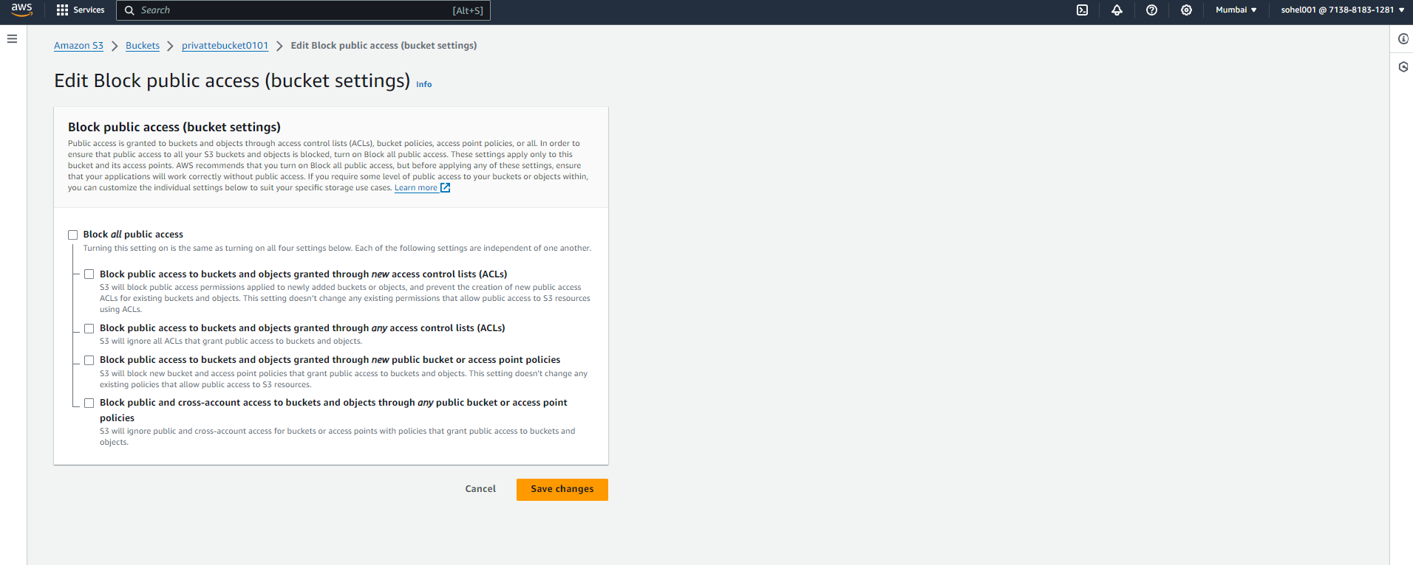

1. When we upload any object in bucket is private by default

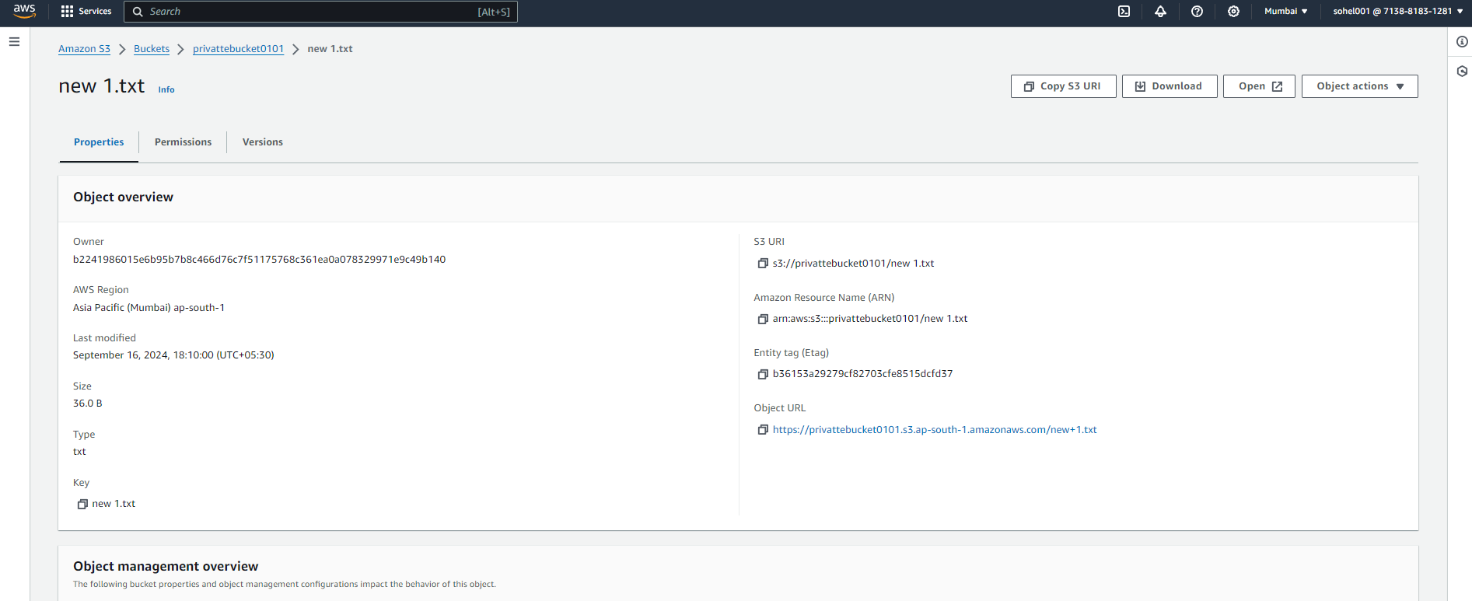

Create a bucket with giving required permission.

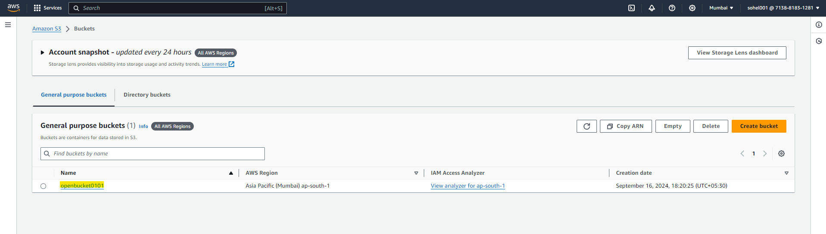

Changes permission of object

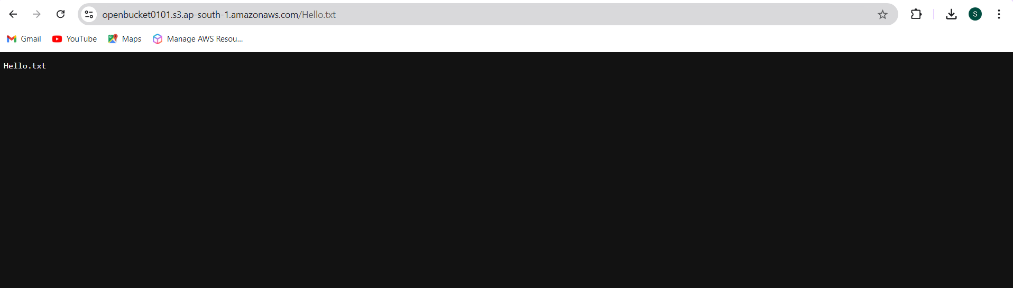

Change storage class of bucket to Intelligent-Tiering

